Electric Fields Test Based on EF mini-games
By Colleen Megowan-Romanowicz and Mina C. Johnson-Glenberg

Name_______________________________________ Date_______________________________________________
Throughout the test, ignore the effects of gravity. The term interaction refers to a push or a pull caused by a force.

- Review - Label the parts of the atom [shown below] AND insert the charge, either 0, + or -.
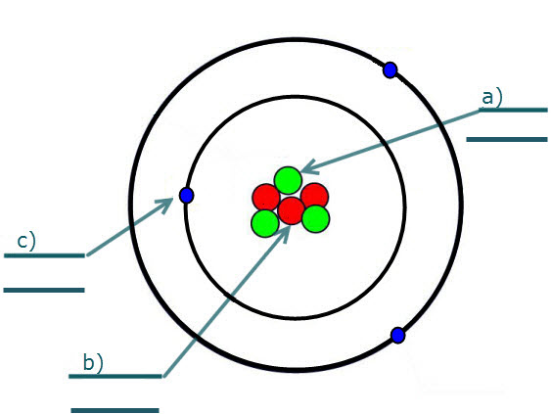
b)Proton

- The electrical interaction between charged particles located a distance from one another is carried by a ___________.
  - Field
  - Force
  - Charge
  - Voltage

- TEST. Are the following particles charged or uncharged. If charged, indicate whether positive or negative. What is net charge?

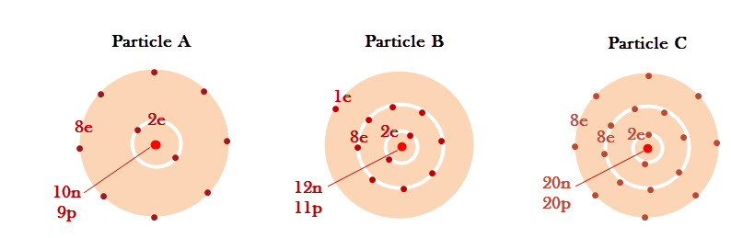

        - ________ b. ________ c. _________

- A neutral plastic strip is rubbed with cotton and becomes positively charged. Why does this happen?

  - The strip gained electrons from the cotton.
  - The strip gained protons from the cotton.
  - The strip lost protons to the cotton.
  - The strip lost electrons to the cotton.

Fill in the blank:
- Charges that are similar _______________ each other.

- Charges that are opposite___________ each other.

- Two oppositely charged spheres are suspended from the ceiling, as shown below. In which direction will the spheres move when the strings are cut?

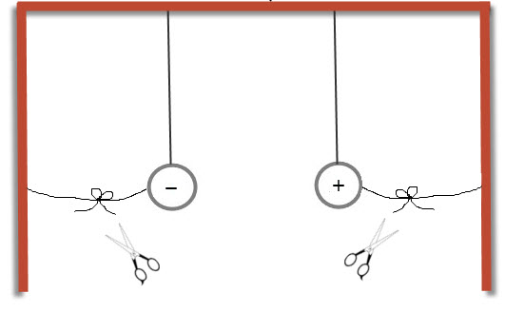

- Two positively charged spheres are suspended from the ceiling, as shown below. In which direction will the spheres move when the strings are cut?

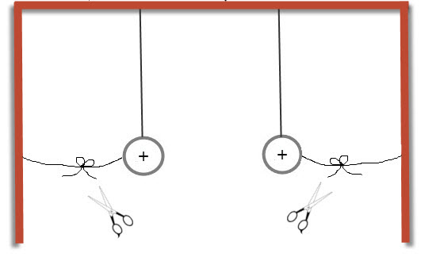

- The electric field at a location in space is

  - The sum of the fields of all charged particles when they are three units apart or less.
  - The sum of the fields of all charged particles when they are one unit apart or less.
  - The sum of the fields of all charged particles.
  - A function of the charge of the particle at that location.

- Consider an electron released in a large room. You “observe” that the electron begins moving upward. It is accelerating and the closer it gets to the ceiling the more it accelerates. This was most likely caused by

  - A positively charged floor
  - A negatively charged ceiling
  - A positively charged ceiling
  - A negatively charged floor

- A negatively charged object is brought near a neutral and balanced metal sphere. As the balloon approaches, the charges within the sphere will distribute in a very specific manner. Which one of the diagrams below properly depicts the distribution of charges in the sphere
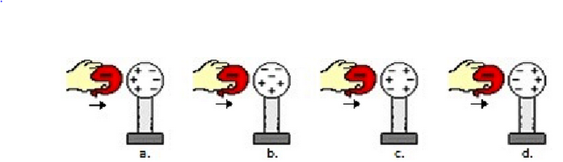
a)
b)
c)
d)
- The symbol for charge is q.
Assume we have two fixed charges. Each has a net charge of +1, thus q₁ = +1 and q₂=+1. If q₁ is changed to +2. How does this change the net force between the charges?

  - It doubles.
  - It is cut in half.
  - It remains the same.
  - It is quadrupled.

13) Explain your answer from above.

- Assume we again have a net charge of +1, thus q₁ = +1 and q₂=+1. If q₁ is changed to -2. How does this change the net force between the charges?

- It doubles.
- It is cut in half.
- It remains the same.
- It is quadrupled.

14) Explain your answer from above.

- Using the following symbols:
Electric Field (E), charge (q), and distance ( r²) or (r) , please write the equation that shows their relationship in the space below.

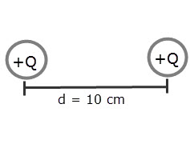
- Two charges are located 10 cm from one another. If each charge is doubled in magnitude, the electric force they would exert on each other would .

  - Double in magnitude
  - Halve in magnitude
  - Quadruple in magnitude X
  - Remain unchanged in both magnitude and direction

- If the distance between two oppositely charged particles is cut in half then the force between the particles is

  - doubled
  - quadrupled
  - halved (cut down to 1/2)
  - quartered (cut down to 1/4)

- If a point charge is fixed and a movable test charge is moved around it while maintaining a distance of 1 meter from the fixed charge, then .

  - only the magnitude of the electric field experienced by the test charge will change
  - only the direction of the electric field experienced by the test charge will change
  - both the magnitude and the direction of the electric field experienced by the test charge will change
  - neither the magnitude nor the direction of the electric field experienced by the test charge will change

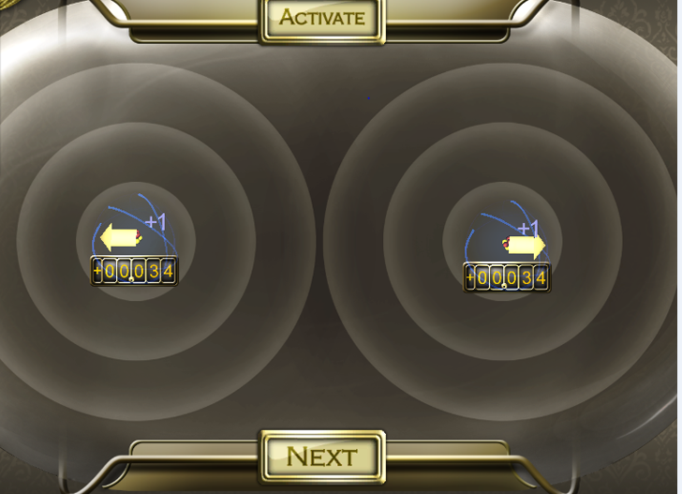
- To the right is a picture of what was described in the previous question. What are two things you could alter on the test charge to make the direction of the vector change?

- A spark can travel between your index finger and a doorknob when they come very close together. Assume that your finger is negatively charged and the doorknob is positively charged. What happened to the electric field just before the spark occurred?

  - The strength of the electric field between your finger and the door knob decreased as the distance between your finger and the knob decreased.
  - The strength of the electric field between your finger and the door knob increased as the distance between your finger and the knob decreased.
  - The excess positive charges on the doorknob moved rapidly off to make a spark.
  - The excess protons between the finger and doorknob moved rapidly off to make a spark.

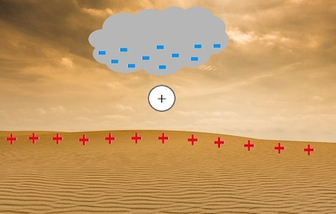
- Imagine a cloud hovering above the desert. The bottom of the cloud is negatively charged. The surface of the earth is positively charged. If a positively charged particle is placed the air between them. Describe in your own words what will happen.

- When a column of air is very ionized and discharges with great force to become neutral again we call that?

_____________________ .

